Full OWASP test against application owned by Zalaris

Introduction:

As part of the quality assurance process, a manual audit has been initiated to validate the results generated by the automated vulnerability scanning tools. Each finding is being reviewed to determine its accuracy and relevance, with the objective of classifying them as either true positives (valid security issues) or false positives (non-exploitable or misidentified issues).
This step ensures the reliability of the final report by eliminating noise from automated tools and confirming the presence and impact of vulnerabilities through manual testing techniques. The scan is done twice a month

Table of Contents
Introduction: 2
TestPeopleHub 3
AlumniDev Portal 5
Helpdesk-Dev Portal 7
Dsm-Dev Portal 7

TestPeopleHub
Broken Access Control - try to access resources without the cookie / authentication parameter
Access the application , capture the request , remove the cookie and then forward the request
The server gives 307 redirect to Login Page
Refer Screenshot attached below for evidence

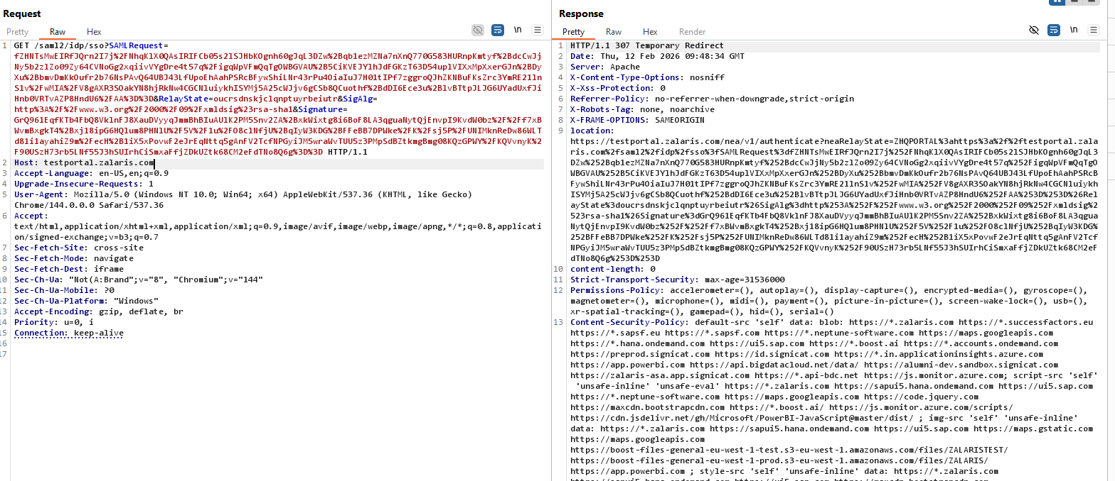

Cross Site Request Forgery

Access protected resource in the application

Capture the request using proxy

Remove the CSRF protection and check for issue the application returns with 403 Forbidden Error.

This confirms that the application is not vulnerable to CSRF vulnerability

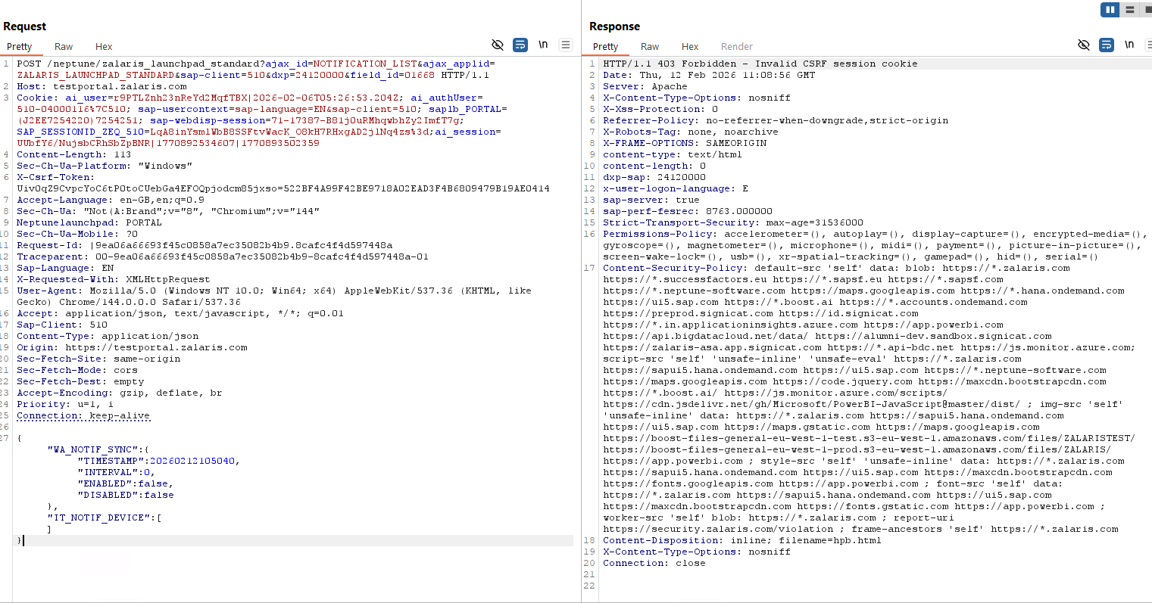

Check all sensitive areas for CSRF request

The sensitive pages are all protected with the CSRF Payload properly

Refer screenshot attached below for evidence

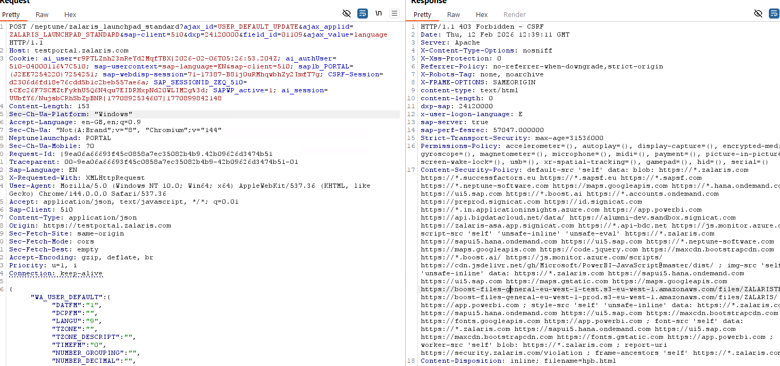

AlumniDev Portal

Broken Access Control - try to access resources without the cookie / authentication parameter

Access the application , capture the request , remove the cookie and then forward the request
The server gives 401 Unauthorized
Refer Screenshot attached below for evidence

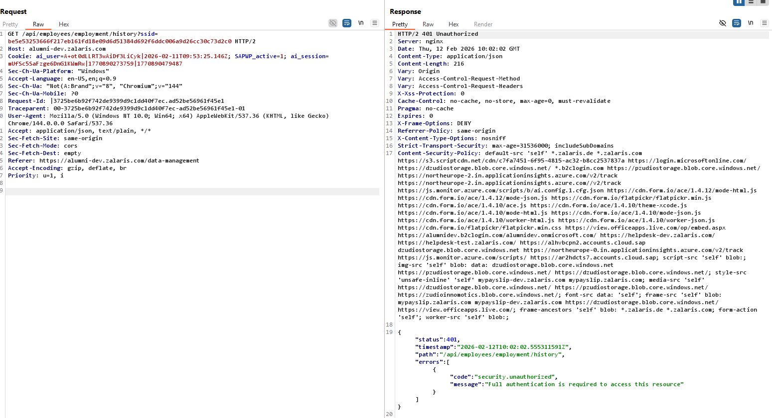

Cross Site Request Forgery

- Access the application capture the request and forward it to repeater
- Remove the CSRF protection from Repeater and forward the request
- The server responds with 403 Forbidden response
- This confirms applciation is not vulnerabl eto CSRF

Helpdesk-Dev Portal

Broken Access Control - try to access resources without the cookie / authentication parameter

Access the application , capture the request , remove the cookie and then forward the request
The server gives 401 Unauthorized
Refer Screenshot attached below for evidence
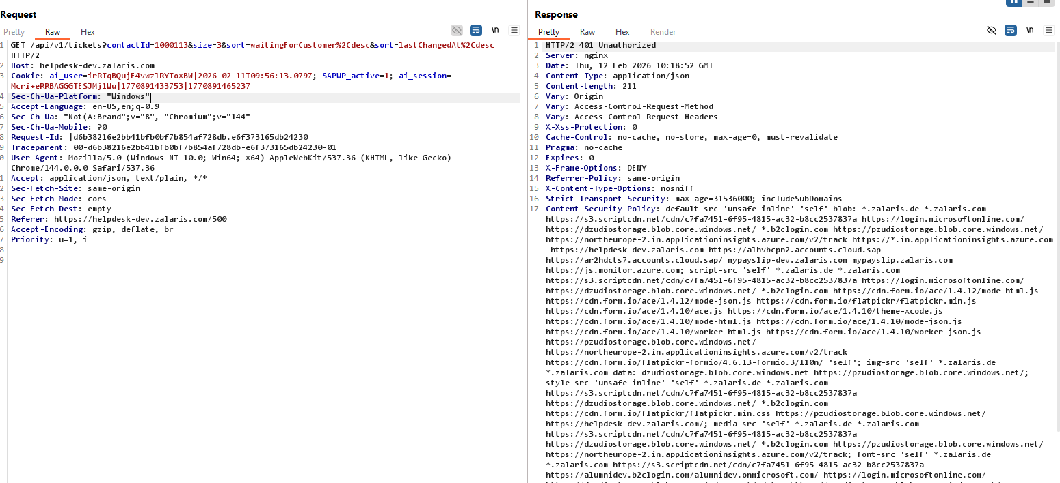

The authorization header is not automatically added to the request . The application is not vulnerable to CSRF

Dsm-Dev Portal

Broken Access Control - try to access resources without the cookie / authentication parameter

Access the application , capture the request , remove the cookie and then forward the request
The server gives 401 Unauthorized
Refer Screenshot attached below for evidence
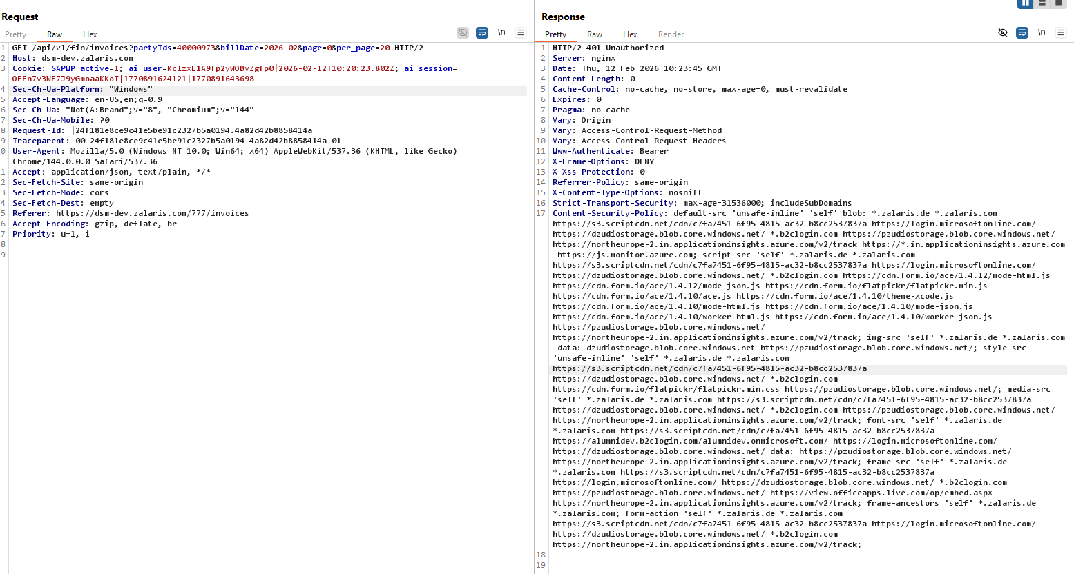

Same with the CSRF the application is not vulnerable to CSRF attack

Cross Site Request Forgery

Access protected resource in the application

Capture the request using proxy

Generate a CSRF HTML request forward the request and analyze the response the browser shows 401 unauthorized

This confirms that the application is not vulnerable to CSRF vulnerability

